SERAD Recognition Dinner and SERAD Student
Design Challenge Award Ceremony
Tuesday, November 13th – 6:30 to 8:30 pm
Kim Son Restaurant
2001 Jefferson St. Houston, TX
Restaurant Telephone: (713) 222-2461
Cost: $35.00 SERAD/ASME members
$15.00 students
Cash bar, entertainment, and more
To make reservations: Jennifer Cooper (T) 832-255-7832 or (E) jcooper@rcp.com
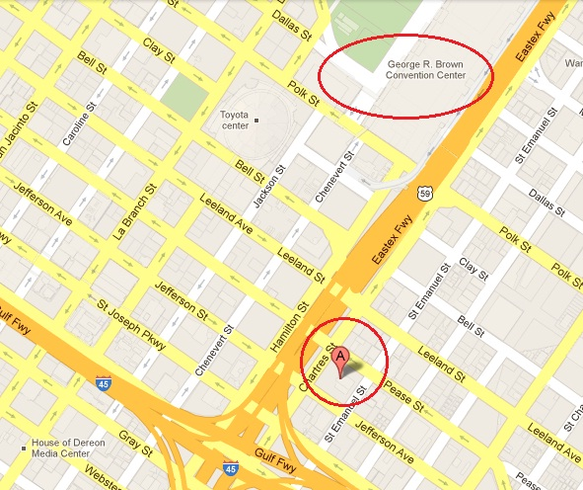
Sponsored by the Safety Engineering & Risk Analysis Division of ASME

